1.graph1 (sum of local peace agreements based on countries )and a.csv

Africa and Middle East has the majority of local peace agreements. And I made a bar chart( a.csv) to see the distribution of countries.

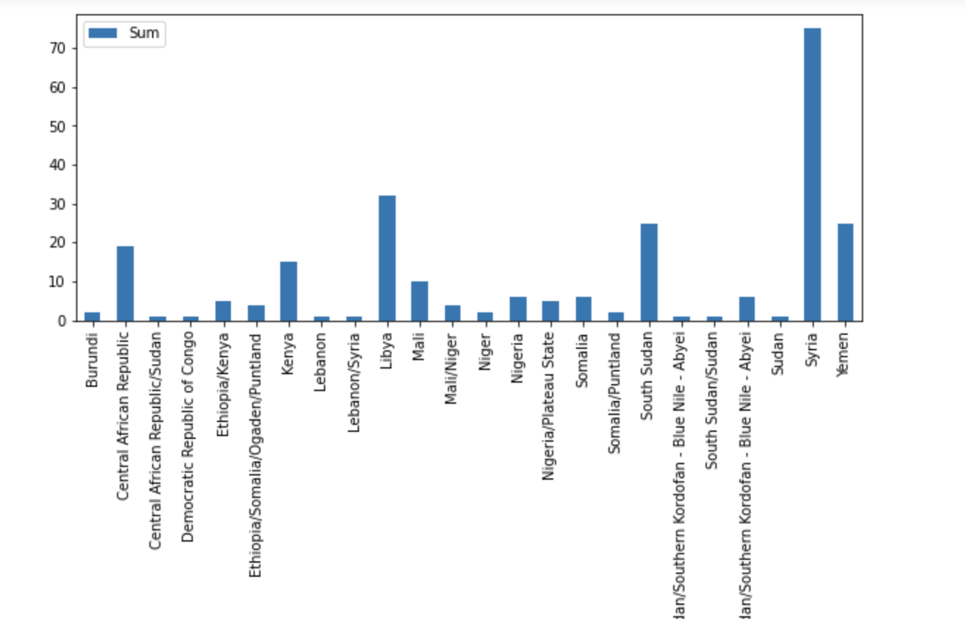

In this graph I find Syria, Yemen, Libya and South Sudan each of which has over 25( including 25 ) local peace agreements. So I decide to analysis these countries.

2.graph2 (number of local peace agreements in four countries in time order) and b.csv

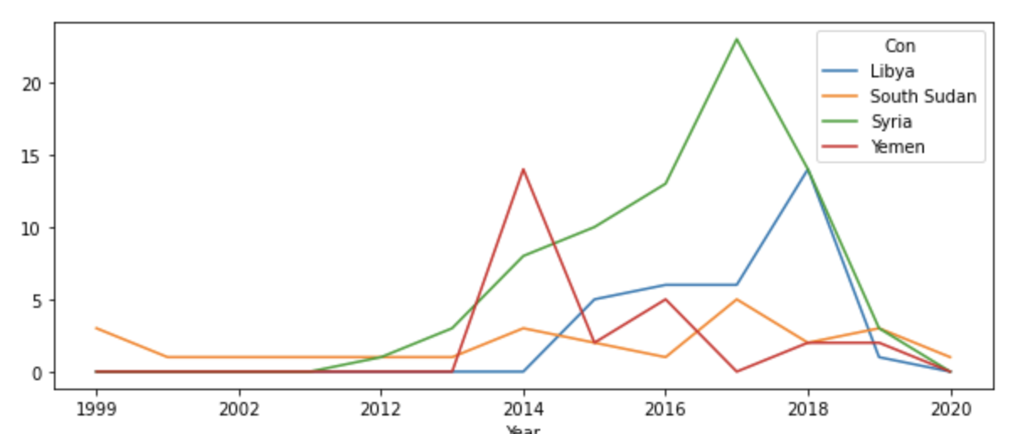

In this graph( b.csv ) I could see there haven’t been so much local peace agreements until 2011. In order to see it clearly how local peace agreements influence peace process in certain history events, I delete the data before 2011. As for why there is an obvious increase after 2011, I think it is related to Arab Spring, which refers to a series of anti-government protests, uprisings, and armed rebellions that spread across much of the Arab world in the early 2010s.

3.graph3 (number of local peace agreements in four countries after 2011) and c.csv

There is the sum chart from 2011-2020.( c.csv)

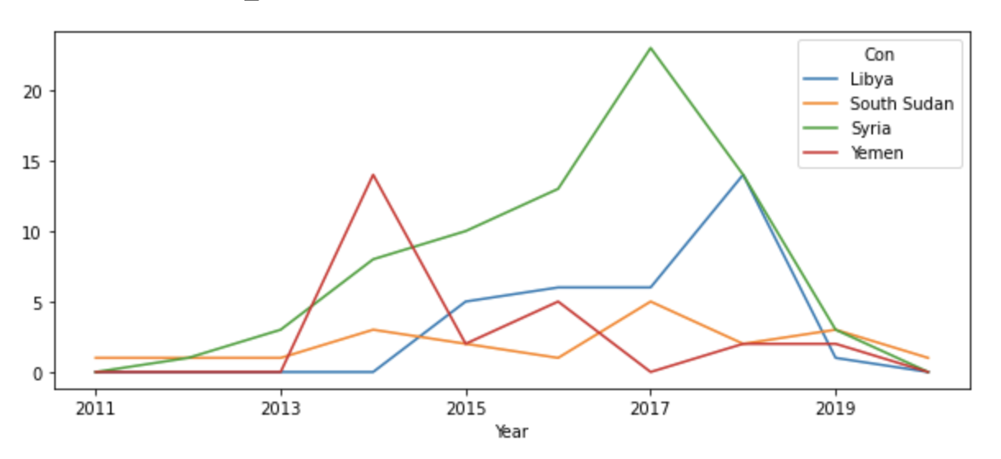

I chose the peak of these countries: 2017 for Syria, 2014 for Yemen, 2018 for Libya, and 2017 for South Sudan.After checking some news I found In Syria, they peaked at 2017, and the US announced the withdrawal in 2018. In South Sudan, they peaked at 2017, and they ended civil war in the next year. They both could be symbols of people appealing to peace and have peace at last. However, In Yemen, 2014 began to have a civil war is the same year of the peak. The same situation happened in Libya as well, they peaked at 2018, and wars began to be more severe in 2019.

So for these four countries, the rises and peaks in the number of local peace agreements have different conclusions. For two of them the peaks mean the peace is coming soon, but for others, the peaks means conflicts are getting worse. These are two opposite conclusions, so I try to introduce more data to analyze.

4.graph4 ( number of all peace agreements in four countries after 2011)and d.csv

Then I’d like to see if there is any relationship between the number of local peace agreements and the number of all peace agreements. So I also introduce the pax_all_agreements data.(d.csv)

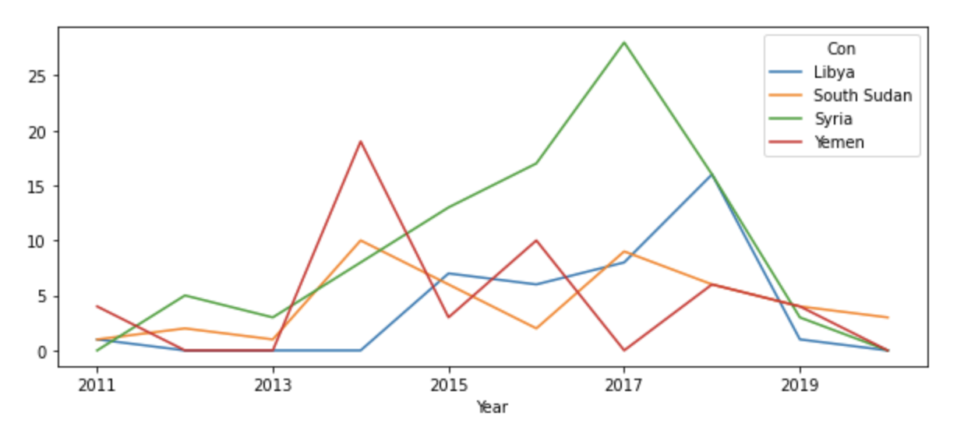

Comparing these two graphs we could see, the trend are the same, so we couldn’t draw conclusion on the relationship between the number of local peace agreements and the war processes, because maybe it isn’t local peace agreements influence conflicts, but other peace agreements do.

5.graph5 (distribution of local peace agreements in all peace agreements ) and e.csv

So, I made a graph on the percentage of local peace agreements. If the percentage equals 1, it means in the same year, there are only local peace agreements are signed.

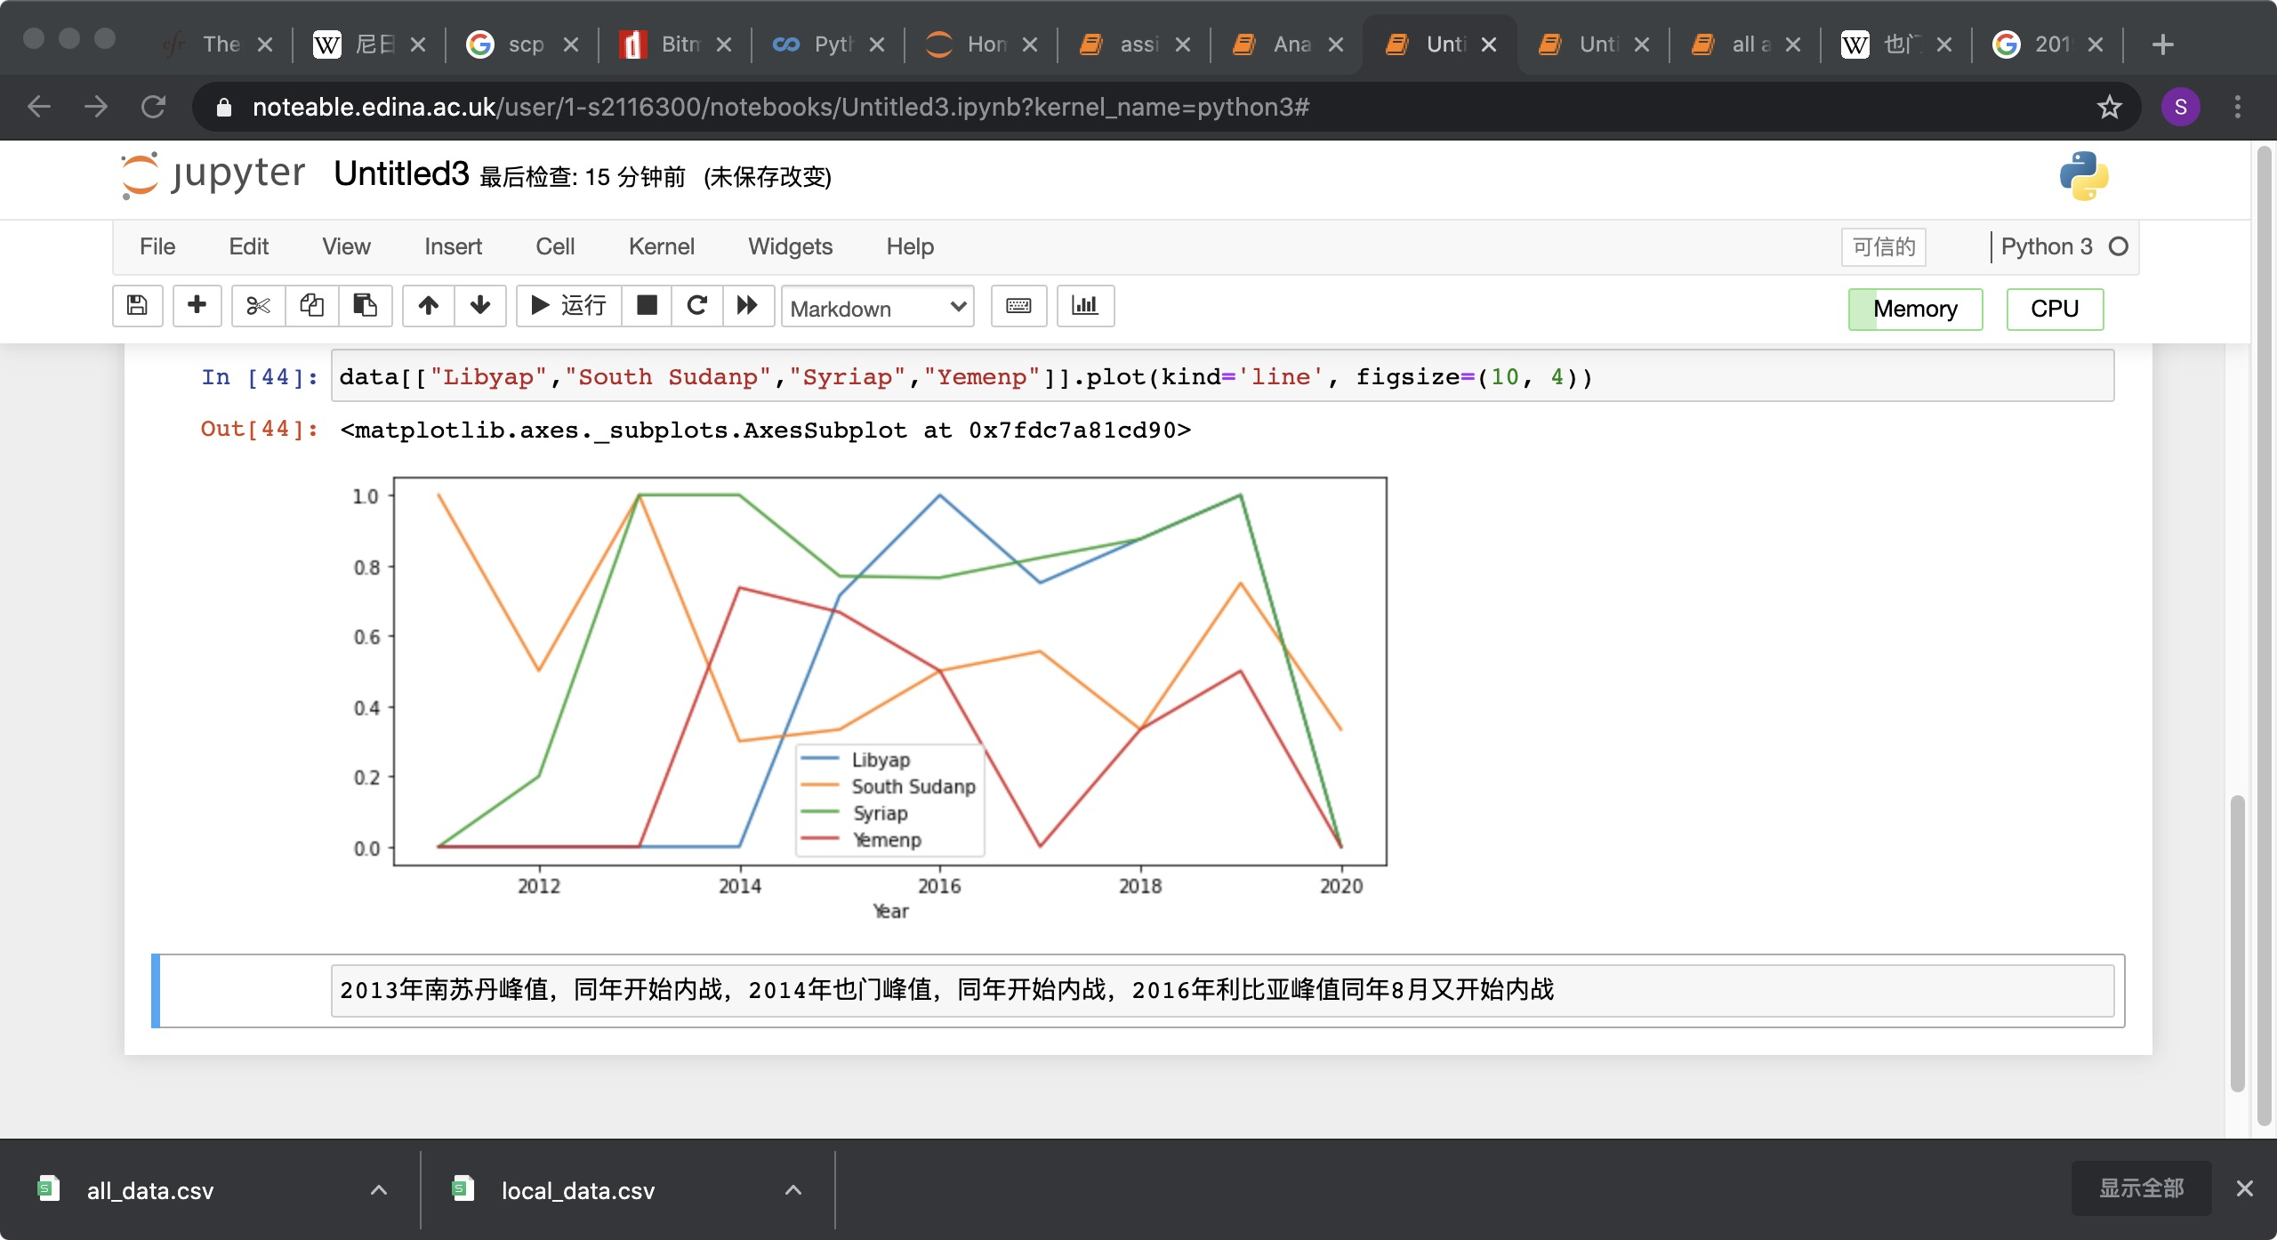

We could see in 2013 South Sudan peaked at this point, and I find in the same year it began to the civil war, in 2014, Yemen peaked, and in the same year, it began to the civil war. In 2016, Libya began to civil war and the percentage of local peace agreements peaked. As for the peak of 2019, in the same year, Turkey, Israel and other surrounding countries involved in Syria war. So we could see peaks of percentage of local peace agreements usually mean the beginning of wars or a new stage of wars.

I guess it is because at the beginning of a war, many citizens are pursuing peace,but there are not much consensus that the two sides could achieve. So they have to sign local peace agreements to seek for local peace.

6.graph6(the percentage of local peace agreements with mediators) and f.csv

Mediator plays an important role in peace agreements. Then I would like to figure the relationship between the number of local peace agreements with mediator and the number of local peace agreements. I also take the percentage of local peace agreements with mediators.

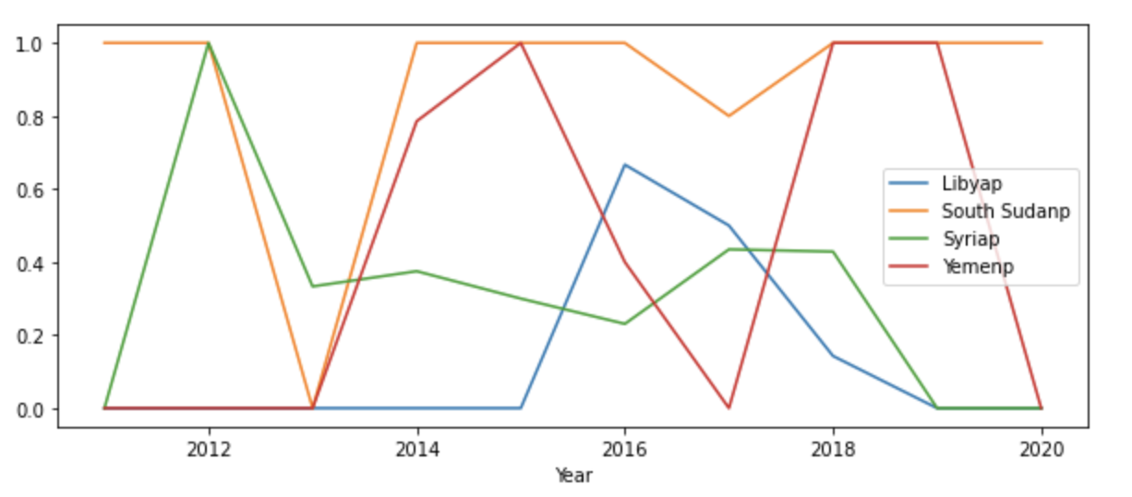

We could see the trend is a little bit like the distribution of local peace agreements in all peace agreements, especially in Libya and Yemen. Then we discuss the factors influence the choices of mediators.